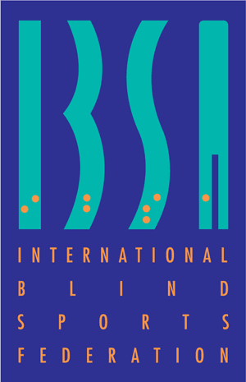

MEDICAL DIAGNOSTICS FORM FOR ATHLETES WITH VISION IMPAIRMENT

- Form must be completed in full and submitted by email to: exd@ibsa-sports.org
- Must be completed by a registered ophthalmologist (or other eye doctor as applicable by country).
- This form is used to determine the athlete’s vision in accordance with the relevant IF classification rules.

Please complete this form legibly in ENGLISH and in CAPITAL letters.

Incomplete forms will be returned and must be re-submitted. Athletes cannot present for classification unless forms have been completed in full, in advance of classification.

- ATHLETE INFORMATION

Last Name:
First Name:
Gender: | Female Male | Date of Birth (dd/mm/yyyy):
Address:
City: |  | Country:
Sport:

- MEDICAL INFORMATION

Current diagnosis with sufficient medical information (see note 1):

Medical history

Age at onset:
Anticipated future procedure(s):
Glasses : | yes / no |  | Contact lenses: |  | yes / no | Prosthesis: | yes / no
Correction: | R….….. L…...…. |  |  |  | R.…….. L……….

Eye Medications

Eventual Drug Allergies:

- ASSESSMENT RESULTS

Visual Acuity

 | With Correction | Without Correction
RE
LE

Type of correction:
Measurement Method:

Visual Field (see note 2) Please attach visual field map.

In degrees (radius) | RE | LE

- MEDICAL PRACTITIONER DECLARATION

I certify that the above-mentioned information is medically appropriate

I certify that there is no contra-indication for this individual to compete at competitive level in the sport identified.
Name:
Medical Speciality:
Registration Number:
Address:
City: |  |  | Country:
Tel.: |  |  | E-mail:
Signature of Medical Practitioner:
Date:

Note 1 Diagnosis
Evidence confirming the diagnosis must be attached and forwarded with this application. The medical evidence should include a comprehensive medical history and the results of all relevant examinations, laboratory investigations and imaging studies. Copies of the original reports or letters should be included where possible. Evidence should be as objective as possible in the clinical circumstances and in the case of non-demonstrable conditions, independent supporting medical opinion will assist this application. Such evidence should include report and graphic results (where applicable) on:
- Pattern Visual Evoked Potentials
- Electroretinography / Electrooculography
- Cerebral Magnetic Resonance Imaging

Note 2
Visual Field must be tested by full-field strategy (30° central field test will not be accepted, by means of any of the following devices):
- Humphrey Field Analyzer, Twinfield (Oculus), Octopus (interzeag), Rodenstock Peristat, Medmont (MAP), Goldmann Perimetry Intensity III/4

It is the responsibility of the Athlete to submit a copy of this Medical Diagnostics Form and all relevant documentation to the appropriate International Federation.

ATHLETES SHOULD PRODUCE A COPY OF THIS DOCUMENT EVERY TIME THEY PRESENT FOR CLASSIFICATION

