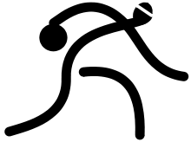

Get Active:

Goalball!

**Louise Gaborieau, B.Ed**

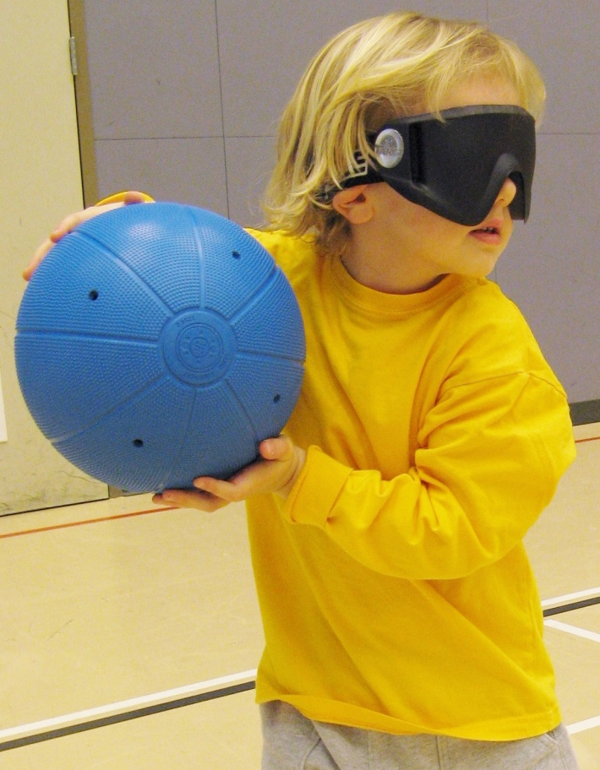

© 2013 Canadian Blind Sports Association

ISBN: 978-8-9880329-4-1

Lesson Plans



*Get Active: Goalball!* was created to help introduce Goalball into the school environment. It is especially written for people who may not have experience teaching, but for those excited about promoting Goalball in schools, such as:

* *Goalball athletes*
* *Coaches*
* *Sport administrators*
* *Parents of athletes*

*Get Active: Goalball!* has helpful tips and has a detailed lesson plan that is broken down into an introductory activity, skill development and modified games. The lesson plan can be modified for younger or older children and includes detailed pictures of each game.

Please note that all activities and games in the lesson plans are specifically for students to

If you do not have the proper equipment suggested in the lessons, here are some possible modifications that you can use.

**Goalballs** If you do not have enough goalballs for every student, you can wrap a plastic bag around a basketball.

You could also use a beach ball with rice inside.

**Eye Shades** Eye Shades or cheesecloth can be used (although be aware that cheesecloth does not completely block out vision)

Swim or ski goggles are effective alternatives, all you need to do is put black tape to cover the eyes (black permanent marker works well, too).

© 2013 Canadian Blind Sports Association

ISBN: 978-8-9880329-4-1

**EQUIPMENT NEEDED**

© 2013 Canadian Blind Sports Association

ISBN: 978-8-9880329-4-1

As the students come into the gym, have them sit an arm’s length apart in the centre circle of the gym (most classes do this already). Be sure to smile at them and say hello as they sit down.

It is very important to wait until all students are settled and quiet. This cannot be emphasized enough. This is the single most important thing you can do to ensure students will focus on what you are teaching them. You can simply put one finger in front of your mouth and wait or look at students who continue to talk. Either way, eventually the students will encourage others to be quiet (even though it may seem like an eternity- it sets the tone for the rest of the class).

Be sure to smile and look the students in the eye as you speak. Once all of the students are quiet and ready to listen, you can start by saying:

1. “Can anyone tell me what we are going to do today?” Hopefully someone will say something about playing Goalball. If not,
2. “Has anyone played Goalball before?” (If yes, you may want to ask them to talk briefly about it- or tell you what they know about Goalball)
3. Now would be a good time to talk about who you are and your experience with Goalball, whether you are a coach, athlete etc. Share whatever you are comfortable with, don’t feel obligated to talk about whether or not you are visually impaired.

Eg: My name is _______________ and I play Goalball. I started playing Goalball ______ years ago…

My name is _____________ and I am here today to teach you all about the Paralympics sport called Goalball.

My name is _____________ and I work for BC Blind Sports. I am a Goalball coach and have played for ____ years.

© 2013 Canadian Blind Sports Association

ISBN: 978-8-9880329-4-1

HELPFUL TIPS

**Before the lesson:**

1. Familiarize yourself with the objectives of the lesson.
2. Know the basic rules and skills of the game. Be prepared to give simplified rules to students and don’t be afraid to teach as you go...don’t be concerned about teaching ALL the rules at once.
3. Be aware of safety procedures. Check for hazards in the gym, and be sure all students are familiar with area.
4. Speak with the teacher or teaching assistant that is working with the student who is visually impaired and be sure you discuss expectations and ask about any special instructions. Be aware that the student who is visually impaired may or may not want to be singled out.
5. If possible, speak to the student who is visually impaired. It is important to make a connection with the student and help them get the most out of the lesson.

**When giving instructions:**

1. Be enthusiastic.
2. Make your instructions clear and simple and at the appropriate level.
3. Speak loud enough so everyone can hear.
4. Speak slowly; even if it sounds really slow to you...it will likely be just right for the children.
5. Speak clearly.

6. Make your voice interesting.

**During the lesson ...**

1. Get the children into action quickly - don't take too long explaining things or the children will lose interest.
2. As you go, you may need to do a lot of “reminding” when students are not getting it. Don’t be afraid of re-teaching a skill or rule.
3. Watch for the children who are doing the skill well - you may be able to use them as an example for the others.
4. Demonstrate what you want done - don't just talk about it! Make sure everyone can see and hear. Use clear, detailed language to ensure understanding.
5. Be encouraging! Always be ready to give praise.
6. Provide fun and enjoyment during play and practice.

You will notice that each lesson in the *Get Active: Goalball! Schools Program* includes the following:

1. ***Introductory Activity***

This involves fun skill activities which include teaching particular movement skills necessary for learning goalball have part of the game in them; also increases the children’s' flexibility and co-ordination.

1. ***Skill Development***

Teaching the children a new skill and letting them practice it using different drills.

1. ***Game***

Often not the whole game but putting what has been learnt into a game situation, so the children know why they have learnt the skill and how it fits into the game.

© 2013 Canadian Blind Sports Association

ISBN: 978-8-9880329-4-1

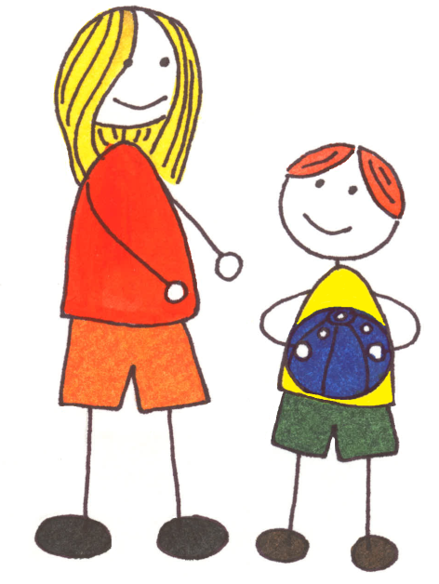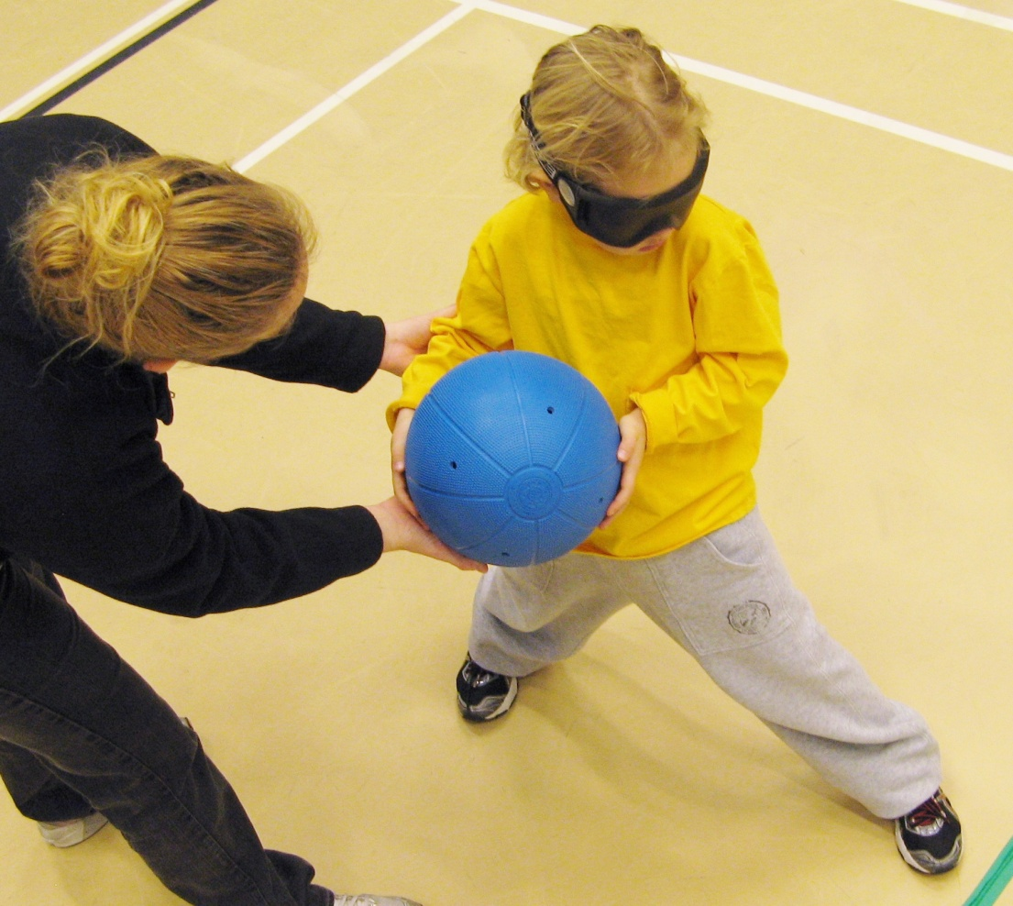

© 2013 Canadian Blind Sports Association

ISBN: 978-8-9880329-4-1

***NOTE: Warm-Down:*** Although most lessons in this manual are not extremely taxing, be aware of the need for a warm-down for participants after strenuous exercise. This involves stretching the muscles and allowing the body to recover. Your co-ordinators, coach or physical education teachers are a good resource for these.

Be sure to demonstrate what you would like the children to perform, or you could use a competent student to demonstrate.

1. You should demonstrate when:

• Showing a new skill.

• Improving an old skill.

2. Demonstrate slowly at first.

3. Explain how the skill you are demonstrating is part of the game of Goalball.

4. Don't give too much information at once. Giving 2-3 points is sufficient.

5. Be sure everybody can see and hear your demonstration.

[](javascript:edit(90198))

**Over and Under Relay** (7-10 minutes)

Equipment: One ball for each team (preferably one with a bell) and enough eyeshades for all

Formation: Have teams line up on the starting line wearing eyeshades

Action: Students pass the ball from the front of the line to the back of the line going over the head and then between the legs. Once the person at the back of the line gets the ball, he/she runs to the front of the line and starts all over again.

**Find Your Way** (5-7 minutes)

Equipment: Gym tape and string, eyeshades

Formation: Students are positioned on the court

Action; Each player starts in their ready position on the court, the coach gives directions (i.e. forward two steps, back three steps, right one step), then the athlete has a certain amount of time to find ready position on the floor.

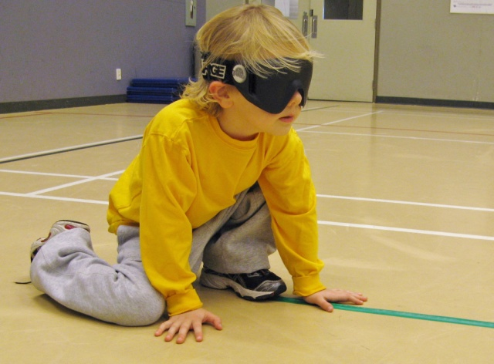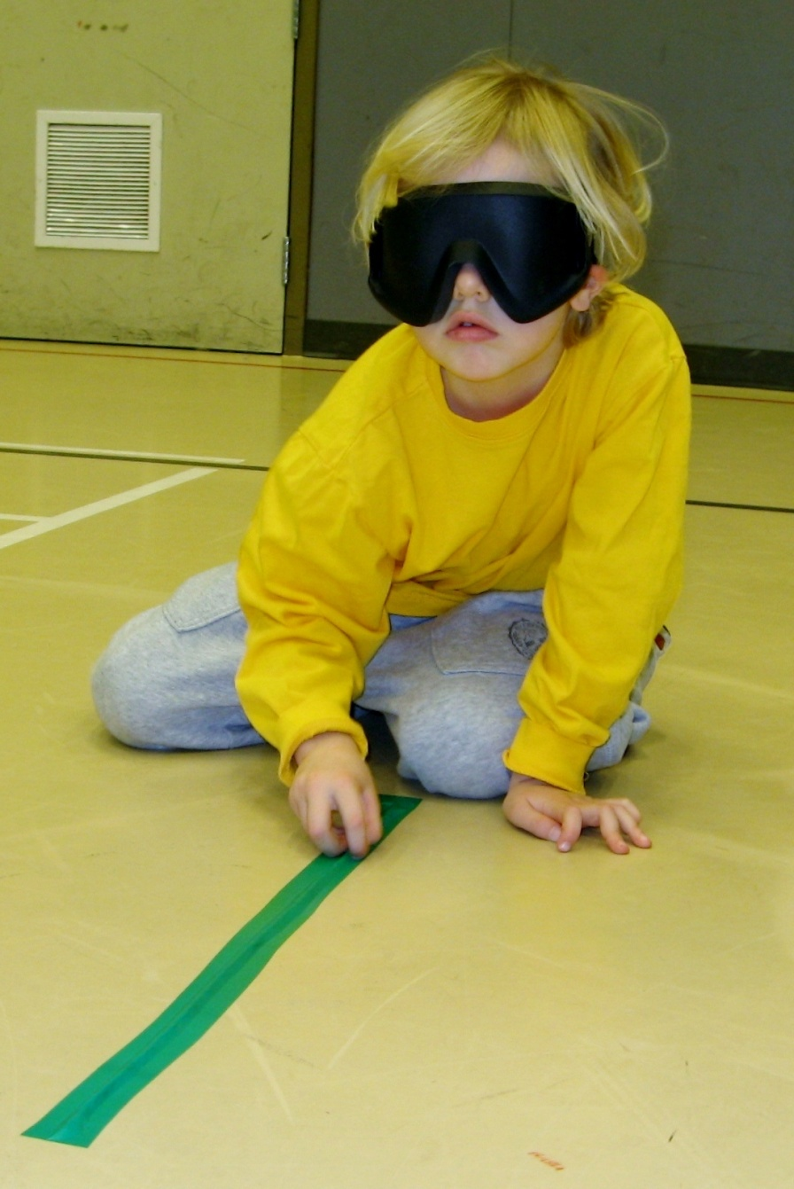

© 2013 Canadian Blind Sports Association

ISBN: 978-8-9880329-4-1

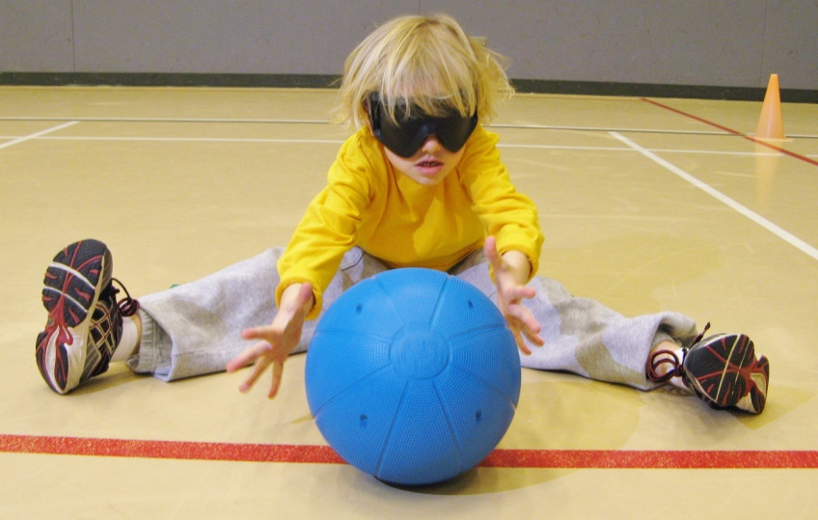[](javascript:edit(90198))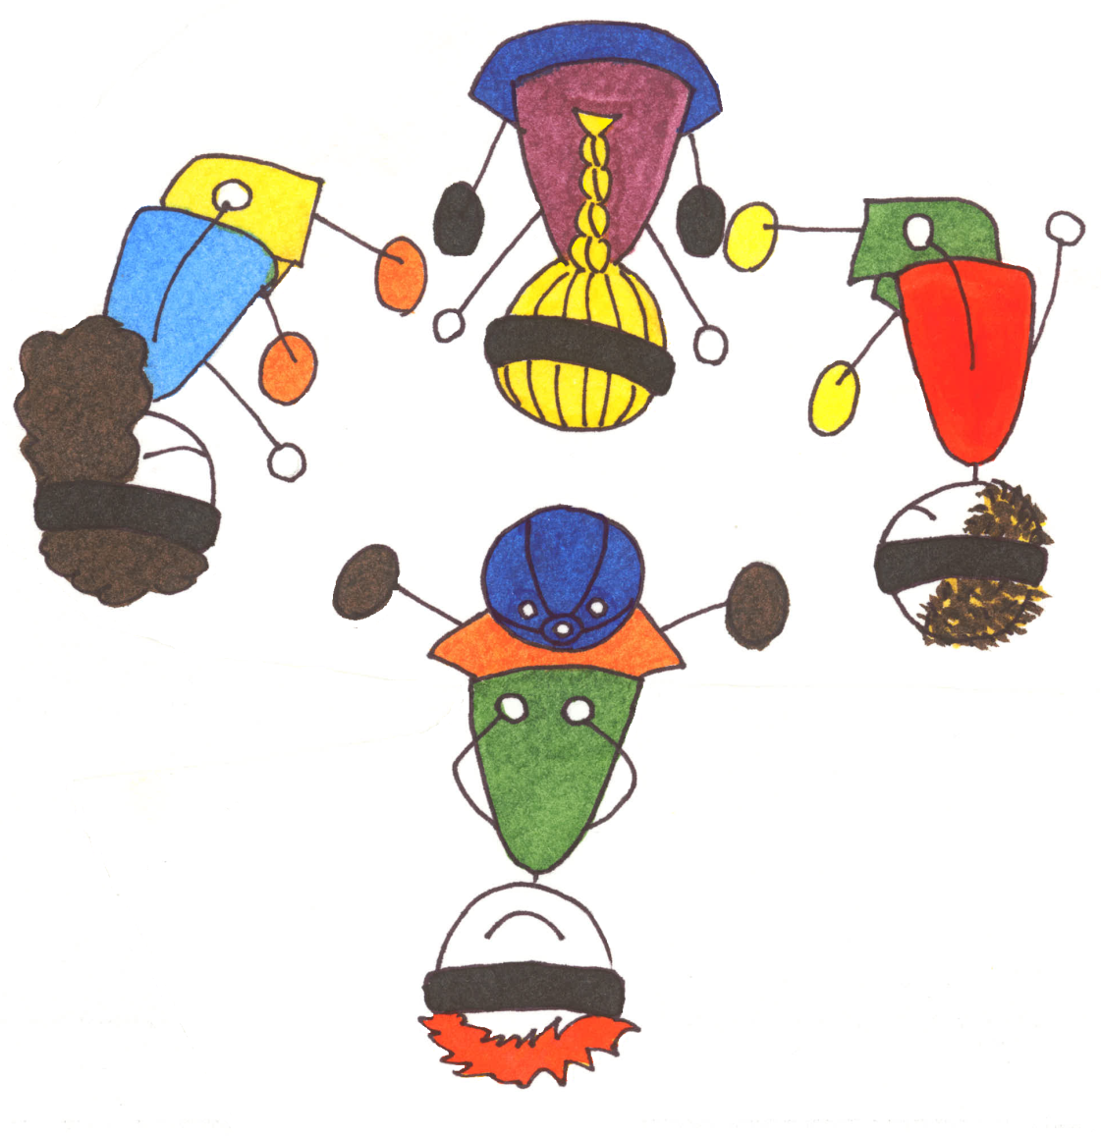

© 2013 Canadian Blind Sports Association

ISBN: 978-8-9880329-4-1

**Star Pass** (5-7 minutes)

Equipment: Eyeshades for all and one goalball per team

Formation: Students should spread out in a star formation

Action: Students will pass to someone across the star; they can communicate when they make a pass (much like they would when passing the ball in Goalball) by tapping the floor or calling out to the person who is passing.

[](javascript:edit(90198))

**Throwing drill** (5-7 minutes)

Objective: Effectively throwing ball to partner using proper underhand technique

Action: Child works one-handed throw with a focus on stepping with alternate foot while their partner stands next to thrower and helps by giving verbal cues such as: “Step with your left foot.” and “Bring the ball back with your arm.” Target partners provide feedback as to accuracy of throw

**Quick Goalball** (10-15 minutes)

Equipment: 6 eyeshades, cones, gym tape, string

Formation: Students are split into teams of 3

Action: Students are introduced to the typical Goalball format. Be sure to reinforce proper positions, rules and proper throwing and passing. Do not bombard the students with all the rules and penalties at the beginning. Feel free to stop during the game to explain a penalty as it occurs. Make the games are quick, as the name suggests allowing for more students to play in a short period. Students can take turns being corner judges as well as referees.

© 2013 Canadian Blind Sports Association

ISBN: 978-8-9880329-4-1



© 2013 Canadian Blind Sports Association

ISBN: 978-8-9880329-4-1

**Knots** (5-7 minutes)

Equipment: Eyeshades

Formation: Students are placed in small groups (perhaps 5-7 students per group depending on the number of students)

Action: Have students stand in a circle formation shoulder to shoulder. Each student holds 2 hands but not from the same person. The object is to untie your knot so your group is standing in a circle with their hands joined. They may rotate their hands without letting go to help accomplish this fun task.

**Treasure Hoop** (5-7 minutes)

Equipment: Four hoola hoops, 10 bean bags for each hoop, eyeshades, place hoops approximately 20 feet apart in a square area

Formation: Children are split up into four equal teams and go stand near one of the hoops

Action: The goal of the game is for children to go and take as many beanbags from the other “treasure hoops” as they can and place them in their own treasure hoop. There is no tagging, no blocking and no guarding allowed. The children must simply take beanbags from the other teams.



© 2013 Canadian Blind Sports Association

ISBN: 978-8-9880329-4-1

**Goalie in the Middle** (10-12 minutes)

Equipment: One goalball for each group and one eyeshade for each group

Formation: Students stand in a circle formation (circle formation players are not wearing eyeshades). One student stands inside the circle wearing an eyeshade.

Action: This activity encourages students to quickly drop and practice the proper side-lying blocking position. The students standing outside of the circle attempt to pass the ball to each other while the person in the middle attempts to block the ball.

**Goalball Stations** (10-15 minutes)

Equipment: Enough goal balls for each station, eyeshades, gym mats,

Formation: Students rotate through stations in small groups

Action: Set up stations as follows:

**STATION 1- Back and Forth**

Students will work with a partner at this station to take turns throwing the goal ball in specified area and then be ready to block the ball as their partner throws it back.



**STATION 2- Block the Ball**

Students take turns kneeling on a mat and the other students will stand in a line and will each throw a ball at the “blocker”. Once they have all thrown one ball, a new blocker kneels down.

**STATION 3- Block It and Pass It**

Have the group make a big enough circle to block the ball to the right or left of them. Coach stands in the center of the circle and throws the ball at an athlete and they must block it, and toss it back to the center. After the athlete blocks the ball they have to pass it to a teammate either next to them or across the circle. Working on listening for who is calling for the ball.

**Pointball**  (20-25 minutes)

Equipment:

Formation: Same as during a regular Goalball game

Action: During this modified game of Goalball, points are awarded for both scoring (3 points) and blocking (1 point). Otherwise, same Goalball rules apply. You can either play for time (e.g. best score after 10 or 20 minutes wins) or first team to a certain number of points (e.g. 25 points). This will depend on how many players you have etc.

*Alternative*: You can incorporate gym mats into this game by placing 3 mats (one for each player on the floor). To block a shot, a defending player must have at least one body part (e.g. hand or foot) touching their mat.

© 2013 Canadian Blind Sports Association

ISBN: 978-8-9880329-4-1

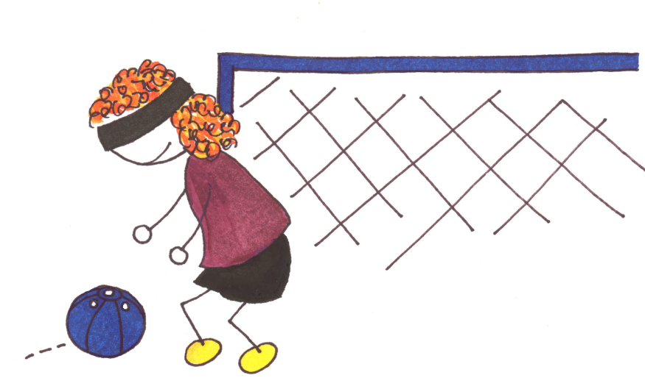

© 2013 Canadian Blind Sports Association

ISBN: 978-8-9880329-4-1

At the end of the lesson, gather all equipment and have the children together in a circle again and take an opportunity to discuss what they did today. This is an excellent way to focus their attention on what they learned and what they observed. Children love to share their thoughts and ideas and it is important for them to reflect on. You could start by sharing what you observed (e.g. any improvements you saw over the course of the lesson) or simply start by asking them some questions.

**QUESTIONS TO ASK:**

Who wants to share what they liked best about today?

Who wants to share something they did well today?

Who wants to tell me something you learned about Goalball?

Does anyone have any questions about Goalball or anything we did today?

You may even want to give students a chance to have a look at the equipment that other blind sports use (ie: blind soccer ball, hockey puck, etc.). You could even share any upcoming Goalball games that might be happening in their area. However you choose to end the lesson, try to be flexible and fun.